What are the dates of the First Punic War?
http://en.wikipedia.org/wiki/First_Punic_War

A. | 753 BC - 509 BC

B. | 218 BC - 201 BC

C. | 264 BC - 241 BC

D. | 431 BC - 404 BC

What does "Pyrrhic victory" mean?
http://en.wikipedia.org/wiki/Pyrrhic_victory

A. | A total destruction of enemy forces

B. | A made-up story about killing a Pyrrha

C. | A battle won at sea

D. | A battle won at too high a cost

- The Romans were not as well schooled in naval warfare as the Carthaginians so instead of the "ramming" technique they used a corvus, a type of bridge, to turn it into essentially a land battle. The word corvus in Latin means:
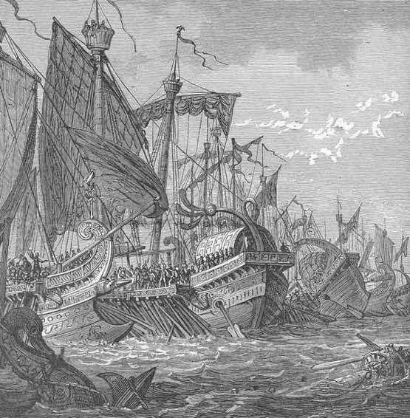

http://en.wikipedia.org/wiki/Corvus_(constellation)

A. | raven

B. | eagle

C. | trireme

D. | romulus

4. | 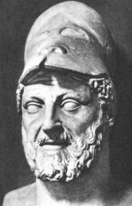The guy pictured here was the father of Hannibal Barca and leader of the Carthaginian army in Spain before the Second Punic War.  http://www.penfield.edu/webpages/jgiotto/resources.cfm?subpage=1479806

A. | Hasdrubal

B. | Hamilcar

C. | Hanno the Great

D. | Scipio

A certain Latin phrase became a motto for the famous politician from Rome, Cato the Elder. He would remark "Carthago delenda est" after almost every speech that he made in the Senate.
"Carthago delenda est" in English means: click here.
5. 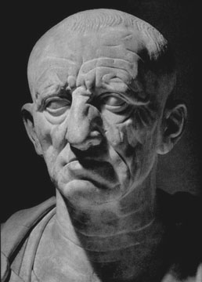

A. | Carthage must be destroyed

B. | Carthage defends the east

C. | Carthage is really weak

D. | Carthage is great, and I love it because the people are the bomb

6. Hannibal Barca led his men, horses, and elephants on an almost unbelievably difficult journey in
order to attack Rome from the north. On his way he crossed two mighty mountain ranges. These two mountain ranges are sown on the map below.
.
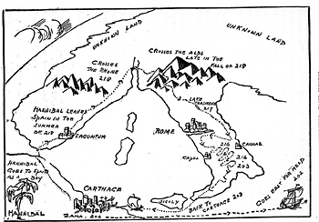

A. | Rocky and Blue

B. | Pyrenees and Alps

C. | Himalayas and Hindu Kush

D. | Alps and Atlas

7. By attacking this Roman ally, Hannibal triggered one of the most important wars of ancient times, the Second Punic War. The Romans failed to send help to this city right away because they underestimated Hannibal.
http://www.hannibalthewarrior.com/Hannibal_at_Saguntum.asp
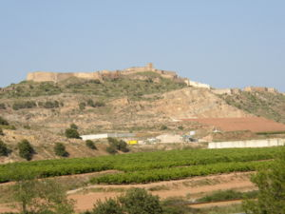

A. | Trebia

B. | Cannae

C. | Saguntum

D. | Trasimene

Q.8) | What fraction of the Roman army was killed at the Battle of Trebia?
 | http://www.youtube.com/watch?v=Wy7mB5ZBvl4

A. | 30,000

B. | 3/4

C. | 2/3

D. | 1/2

9. The next major battle came at Lake Trasimene. Here Hannibal ambushed the over aggressive consul in charge of the Roman forces that day. His name was?
http://www.youtube.com/watch?v=s-jd79hDFYU
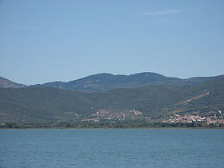

A. | Tiberius Sempronius Longus

B. | Gnaeus Servilius Geminus

C. | Gaius Flaminius

D. | Publius Cornelius Scipio

10. After these two terrible defeats, the Senate appointed a dictator who refused to meet Hannibal in a pitched battle. Instead he kept his troops close to Hannibal, hoping to exhaust him in a
long war of attrition. This guys name was?
http://en.wikipedia.org/wiki/Fabian_strategy
.
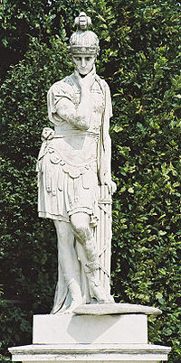

A. | Fabius Maximus

B. | Gnaeus Servilius Geminus

C. | Lucius Aemilius Paullus

D. | Gaius Terentius Varro

11.
The Fabian strategy of stalling was very unpopular with Romans as they believed it showed weakness so the consul in charge that day, Varro, became too aggressive and despite a large numerical advantage lost the second most Roman men in any battle. Exact numbers are hard to come up with, but around this many Romans and allies died that day during the Battle of Cannae.

http://en.wikipedia.org/wiki/Battle_of_Cannae
hannibal

A. | 15,000

B. | 45,000

C. | 95,000

D. | 200,000

12. | This many Carthaginians died at Zama when Scipio used some of Hannibal's tactics against him:  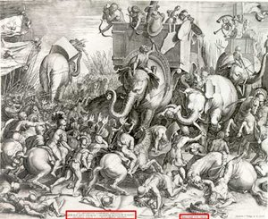
 | http://en.wikipedia.org/wiki/Battle_of_Zama

A. | 5000

B. | 10000

C. | 15000

D. | 20000

13. | Hannibal was chased by both Carthage and Rome after Zama. When his enemies finally found him, he committed suicide. He did this by?  http://ryanbroussard.tripod.com/id3.html

A. | taking poision

B. | hanging himself

C. | gunshot

D. | drowning himself

14. | True or false the Roman sowed salt on the ground after finally defeating the Carthaginians?

A. | True

B. | False

